**ANALYSIS-3**

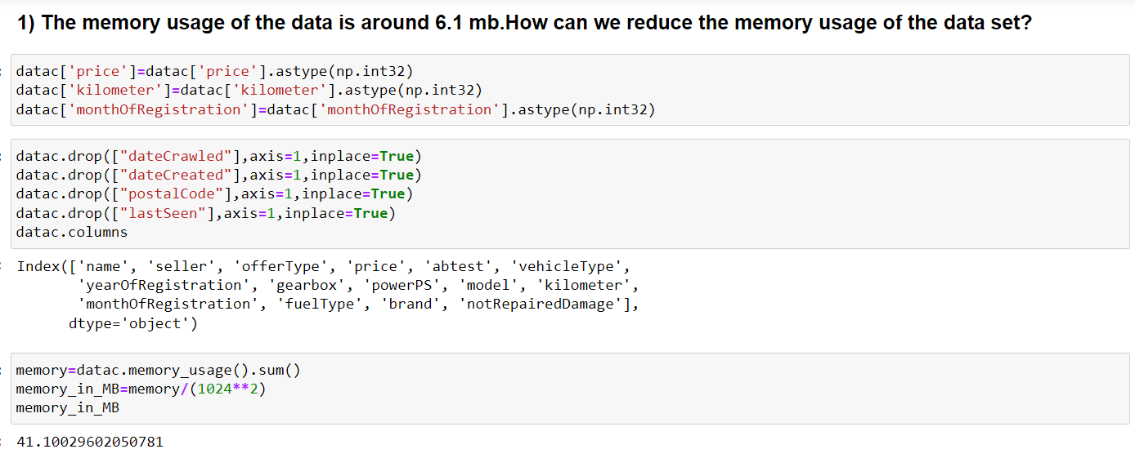

After performing the operations mentioned in your code snippet, the memory usage of the datac dataframe is 41.10 MB.

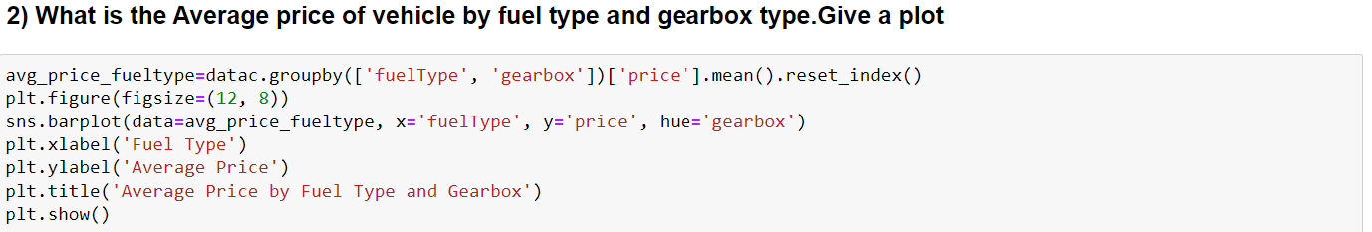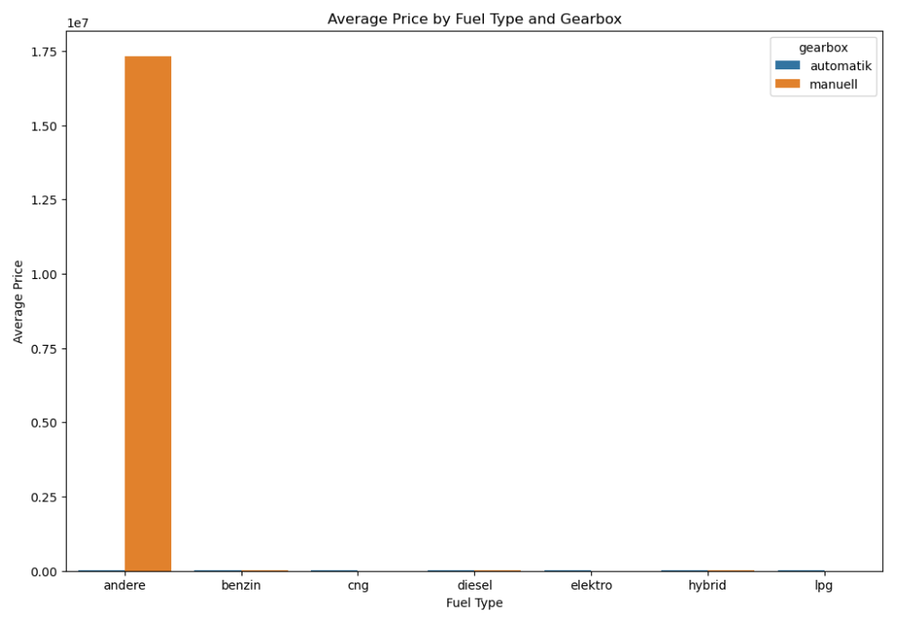

By seeing the above picture we can easily say that andere vehicles having the Highest price by fuel type and gearbox when compared to others

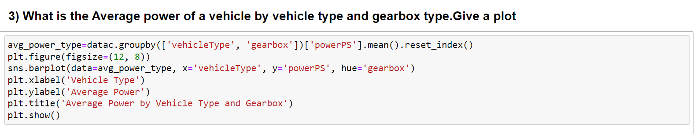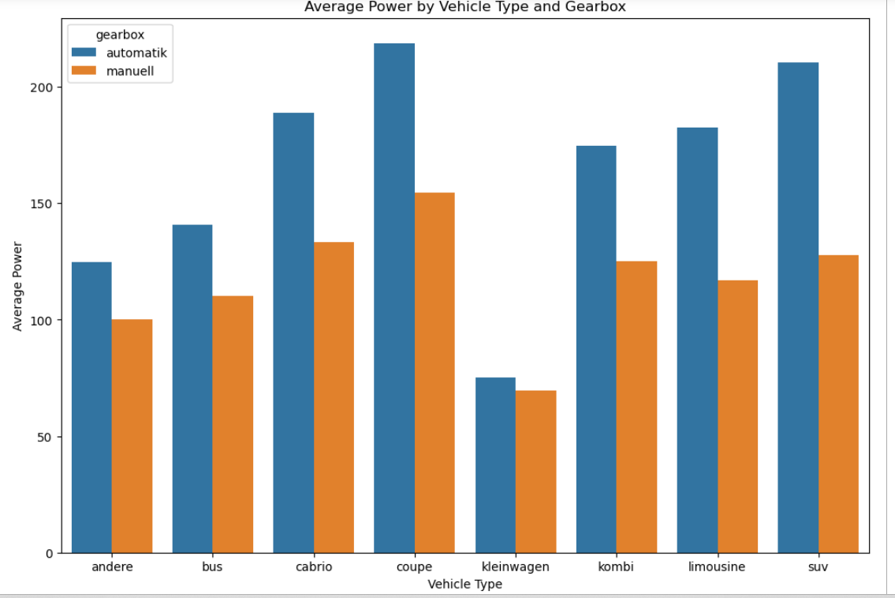

In automatic coupe type of vehicles having high power and In manual also coupe type of vehicles having highest power

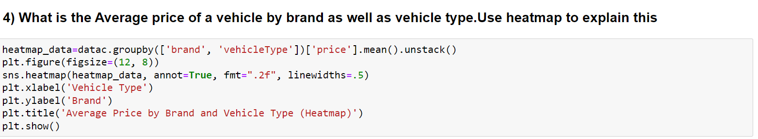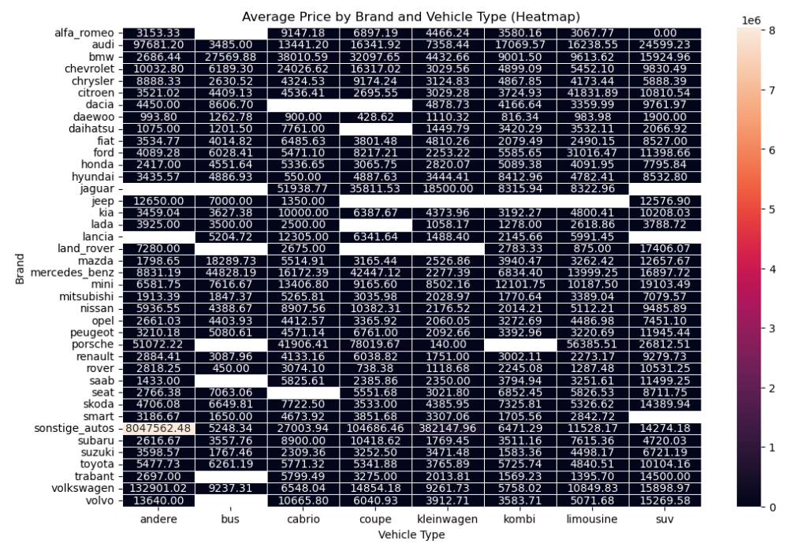

Here the image of heat map shows that the all values of average prices for the vehicle type and brand at a time